**John Arena**

**Professor Gertner**

**CSC 342/343**

**Lab 1**

**Due 2/20/19**

**Spring 2019**

**Table of Contents**

**Note: Files sent to your email address on 12/3/18**

**Section 1) Objective pg. 3**

**Section 2) Description and Specification pg. 3**

**Section 3) Simulations pg. 24**

**Section 4) Demonstration Video pg. 40**

**Section 5) Conclusion pg. 40**

**Section 1) Objective**

For this lab, the objective will be to apply everything we’ve learned about Quartus II in the tutorials. I will be doing the following:

* Building the following circuits using Object form and VHDL: 2to1 Multiplexer, 1-bit Half Adder, 1-bit Full Adder, 3to8 Decoder and 8to3 Encoder
* Verifying their correctness using waveform simulations
* Writing testbench files in VHDL to test the correct of the designs
* Programming pin assignments for the board

**Section 2) Description and Specifications**

2to1 Multiplexer

The first circuit I will be designing is a 2to1 **Multiplexer**. A multiplexer, also known as a mux, is “basically a switch that passes one of its data inputs through to the output, as a function of a set of select inputs”[1]. One of their uses is to choose among several multibit input numbers. The typical logic symbol of a 2to1 Multiplexer is shown below in Figure **1**

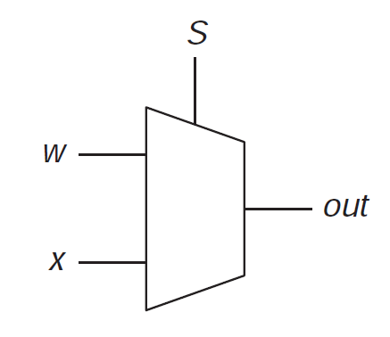

Figure 1: 2to1 Multiplexer

The way a 2to1 multiplexer works as follows. If the select input, *S*, is equal to 0, the output, *out*, is equal to the value of X. If the select input is equal to 1, the output is equal to the value of Y. Table **1** below shows the truth table of a 2to1 Mux. I will denote the two inputs as X and Y and the output as M.

|  |  |  |  |
| --- | --- | --- | --- |
| **X** | **Y** | **S** | **M** |
| **0** | **0** | **0** | **0** |
| **0** | **0** | **1** | **0** |
| **0** | **1** | **0** | **0** |
| **0** | **1** | **1** | **1** |
| **1** | **0** | **0** | **1** |
| **1** | **0** | **1** | **0** |
| **1** | **1** | **0** | **1** |
| **1** | **1** | **1** | **1** |

Table 1: 2to1 Multiplexer Truth Table

A simplified table is shown in Table **2** below

|  |  |
| --- | --- |
| **S** | **M** |
| **0** | **X** |
| **1** | **Y** |

Table 2: 2to1 Multiplexer - Simplified Truth Table

We can derive the Boolean algebra expression of a 2to1 multiplexer from table **1** Looking at the table, we get the following $$M=XS^{'}+YS$$

Equation 1: Out of 2to1 Mux

This can be composed of two AND gates, one OR gate and one NOT gate. The design of AND, OR and NOT gates can be designed using transistors, but are not within the scope of this course, so shall not be discussed.

The inputs and outputs will be assigned as follows on our board, seen in Figure **2** below. It comes from the pin assignment text file for this circuit.

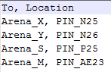

Figure 2: Pin Assignment for 2to1 Mux

The format is as follows. To, Location. To is the input/outputs from the object/vhdl file. The Location is the appropriate pins used for inputs and outputs. The pins are gotten from the pin assignment file.

On the next page in Figure **3** is the design I made in Quartus for the 2to1 Multiplexer.

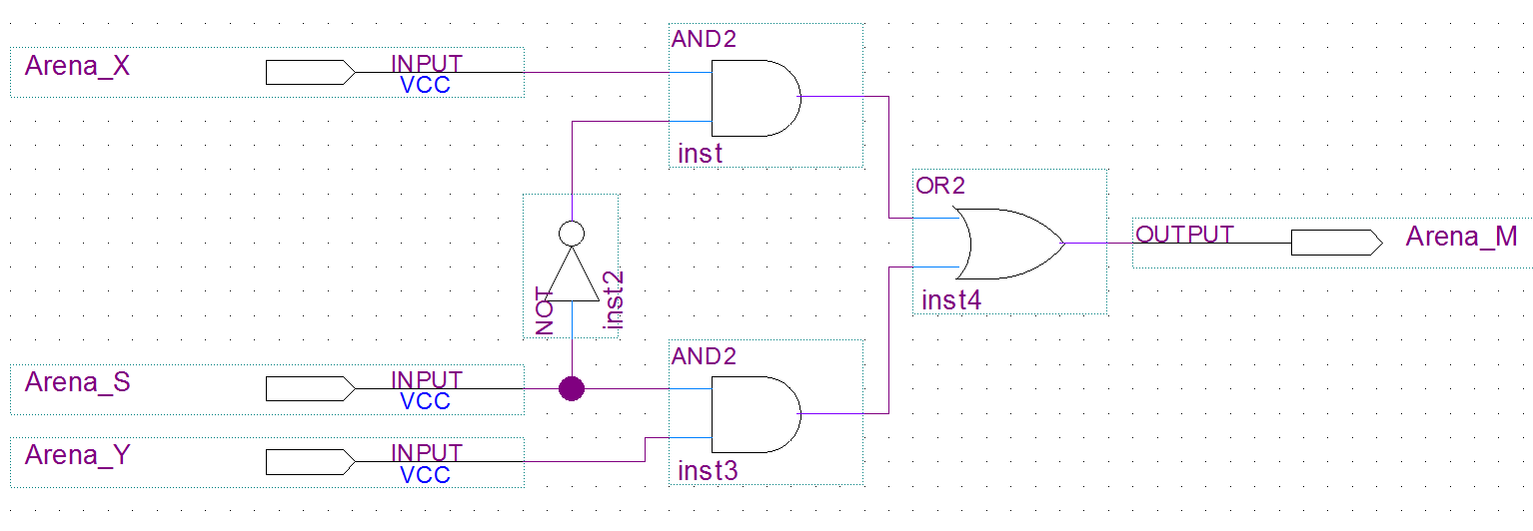

Figure 3: 2to1 Multiplexer at the Logic Level

As can be seen in the figure, the output consists of an 2-input OR gate connected to two 2-input AND gates with the appropriate inputs, with one AND gate having it’s input connected to a NOT gate just as described in Equation 1.

Below in Figure **4** is the VHDL code for the circuit, generated by the MegaWizard tool.

-- (First, Last) John Arena - CSC 342/343 - Lab 1 - Spring 2019 Due: 2/20/19

-- megafunction wizard: %LPM_MUX%

-- GENERATION: STANDARD

-- VERSION: WM1.0

-- MODULE: LPM_MUX

-- ============================================================

-- File Name: Arena_muxLPM.vhd

-- Megafunction Name(s):

-- LPM_MUX

--

-- Simulation Library Files(s):

-- lpm

-- ============================================================

-- ************************************************************

-- THIS IS A WIZARD-GENERATED FILE. DO NOT EDIT THIS FILE!

--

-- 13.0.1 Build 232 06/12/2013 SP 1 SJ Web Edition

-- ************************************************************

--Copyright (C) 1991-2013 Altera Corporation

--Your use of Altera Corporation's design tools, logic functions

--and other software and tools, and its AMPP partner logic

--functions, and any output files from any of the foregoing

--(including device programming or simulation files), and any

--associated documentation or information are expressly subject

--to the terms and conditions of the Altera Program License

--Subscription Agreement, Altera MegaCore Function License

--Agreement, or other applicable license agreement, including,

--without limitation, that your use is for the sole purpose of

--programming logic devices manufactured by Altera and sold by

--Altera or its authorized distributors. Please refer to the

--applicable agreement for further details.

**LIBRARY** ieee**;**

**USE** ieee**.**std_logic_1164**.all;**

**LIBRARY** lpm**;**

**USE** lpm**.**lpm_components**.all;**

**ENTITY** Arena_muxLPM **IS**

**PORT**

**(**

Arena_data0 **:** **IN** STD_LOGIC **;** --Appropriate inputs/ outputs

Arena_data1 **:** **IN** STD_LOGIC **;** --for the external interface

Arena_sel **:** **IN** STD_LOGIC **;**

Arena_result **:** **OUT** STD_LOGIC

**);**

**END** Arena_muxLPM**;**

**ARCHITECTURE** SYN **OF** arena_muxlpm **IS**

-- type STD_LOGIC_2D is array (NATURAL RANGE <>, NATURAL RANGE <>) of STD_LOGIC;

**SIGNAL** Arena_sub_wire0 **:** STD_LOGIC_VECTOR **(**0 **DOWNTO** 0**);** Various vars

**SIGNAL** Arena_sub_wire1 **:** STD_LOGIC **;**

**SIGNAL** Arena_sub_wire2 **:** STD_LOGIC **;**

**SIGNAL** Arena_sub_wire3 **:** STD_LOGIC_2D **(**1 **DOWNTO** 0**,** 0 **DOWNTO** 0**);**

**SIGNAL** Arena_sub_wire4 **:** STD_LOGIC **;**

**SIGNAL** Arena_sub_wire5 **:** STD_LOGIC **;**

**SIGNAL** Arena_sub_wire6 **:** STD_LOGIC_VECTOR **(**0 **DOWNTO** 0**);**

**BEGIN**

Arena_sub_wire4 **<=** Arena_data0**;** --Appropriate assignments

Arena_sub_wire1 **<=** Arena_sub_wire0**(**0**);**

Arena_result **<=** Arena_sub_wire1**;**

Arena_sub_wire2 **<=** Arena_data1**;**

Arena_sub_wire3**(**1**,** 0**)** **<=** Arena_sub_wire2**;**

Arena_sub_wire3**(**0**,** 0**)** **<=** Arena_sub_wire4**;**

Arena_sub_wire5 **<=** Arena_sel**;**

Arena_sub_wire6**(**0**)** **<=** Arena_sub_wire5**;**

LPM_MUX_component **:** LPM_MUX

**GENERIC** **MAP** **(** -- Passing information to an entity

lpm_size **=>** 2**,**

lpm_type **=>** "LPM_MUX"**,**

lpm_width **=>** 1**,**

lpm_widths **=>** 1

**)**

**PORT** **MAP** **(** --Port maps

data **=>** Arena_sub_wire3**,**

sel **=>** Arena_sub_wire6**,**

result **=>** Arena_sub_wire0

**);**

**END** SYN**;**

-- ============================================================

-- CNX file retrieval info

-- ============================================================

-- Retrieval info: PRIVATE: INTENDED_DEVICE_FAMILY STRING "Cyclone II"

-- Retrieval info: PRIVATE: SYNTH_WRAPPER_GEN_POSTFIX STRING "0"

-- Retrieval info: PRIVATE: new_diagram STRING "1"

-- Retrieval info: LIBRARY: lpm lpm.lpm_components.all

-- Retrieval info: CONSTANT: LPM_SIZE NUMERIC "2"

-- Retrieval info: CONSTANT: LPM_TYPE STRING "LPM_MUX"

-- Retrieval info: CONSTANT: LPM_WIDTH NUMERIC "1"

-- Retrieval info: CONSTANT: LPM_WIDTHS NUMERIC "1"

-- Retrieval info: USED_PORT: data0 0 0 0 0 INPUT NODEFVAL "data0"

-- Retrieval info: USED_PORT: data1 0 0 0 0 INPUT NODEFVAL "data1"

-- Retrieval info: USED_PORT: result 0 0 0 0 OUTPUT NODEFVAL "result"

-- Retrieval info: USED_PORT: sel 0 0 0 0 INPUT NODEFVAL "sel"

-- Retrieval info: CONNECT: @data 1 0 1 0 data0 0 0 0 0

-- Retrieval info: CONNECT: @data 1 1 1 0 data1 0 0 0 0

-- Retrieval info: CONNECT: @sel 0 0 1 0 sel 0 0 0 0

-- Retrieval info: CONNECT: result 0 0 0 0 @result 0 0 1 0

-- Retrieval info: GEN_FILE: TYPE_NORMAL Arena_muxLPM.vhd TRUE

-- Retrieval info: GEN_FILE: TYPE_NORMAL Arena_muxLPM.inc FALSE

-- Retrieval info: GEN_FILE: TYPE_NORMAL Arena_muxLPM.cmp TRUE

-- Retrieval info: GEN_FILE: TYPE_NORMAL Arena_muxLPM.bsf FALSE

-- Retrieval info: GEN_FILE: TYPE_NORMAL Arena_muxLPM_inst.vhd FALSE

-- Retrieval info: LIB_FILE: lpm

Figure 4 : VHDL Code for 2to1 Mux

1-bit Half Adder

The second circuit I will be designing is a **1-bit Half Adder.** A 1-bit Half Adder is a circuit that can add two 1-bit numbers, and produce a Sum and a possible carry over. We know from basic math for example, if we had 3+3, we will have a sum of 6 with a carry over of 0, but 7+4 will produce a sum off 11 with a carry over of 1. We know from Boolean algebra that a 1-bit number is base two, since it can only have two digits, either a 0 or a 1. Since that is the case, let’s quickly review the rules of binary addition of 1-bit numbers

$$0+0=0 \\ 0+1=1 \\ 1+0=1 \\ 1+1=0, Carry 1$$

Knowing these rules, below in Table **3** describes the functionality of a 1-bit half adder.

|  |  |  |  |
| --- | --- | --- | --- |
| **X** | **Y** | **Sum** | **Carry Out** |
| **0** | **0** | **0** | **0** |
| **0** | **1** | **1** | **0** |
| **1** | **0** | **1** | **0** |
| **1** | **1** | **0** | **1** |

Table 3: 1-bit Half Adder Truth Table

We can derive the Boolean algebra expression of a 1-bit adder from table **3**. Looking at the table, we get the following in equation **2** below. $$Sum=X^{'}Y+XY^{'} \\ Carry Out=XY$$

Equation 2: Out of 2to1 Mux

Looking at these functions, we can see Sum is an XOR function of variables X and Y, while Carry Out is an AND function of X and Y. These will be created using an XOR gate and an AND gate.

The inputs and outputs will be assigned as follows on our board, seen in Figure **5** below. It comes from the pin assignment text file for this circuit.

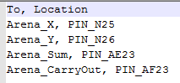

Figure 5: Pin Assignment for 2to1 Mux

There is 2 input switches used and 2 output LEDs. Below in Figure **6** is the design I made in Quartus for the 1-bit Half-Adder.

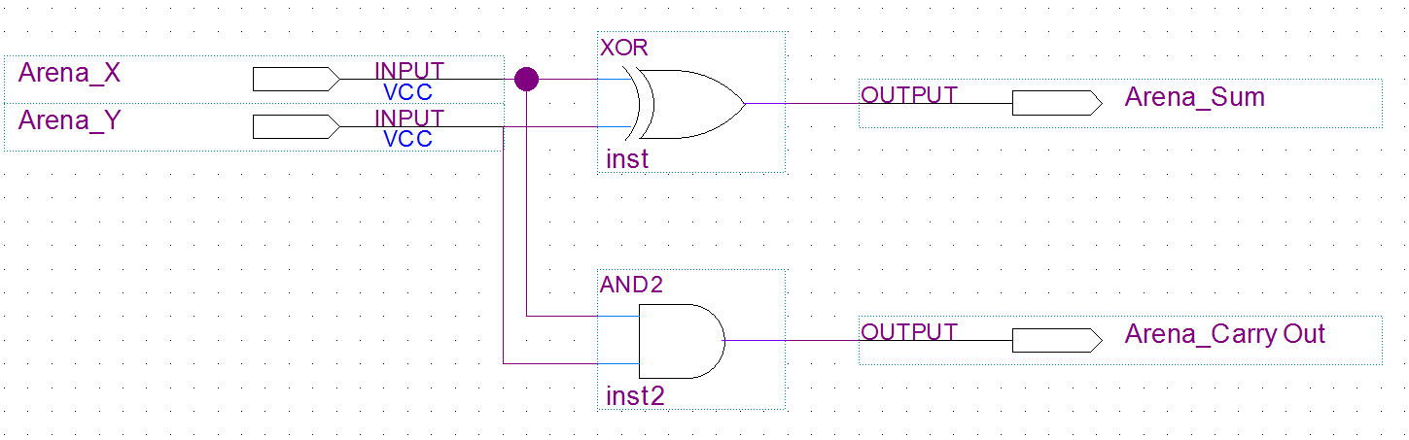

Figure 6: 1-bit Half Adder at Gate Level

As seen in the figure, there are two inputs, X and Y going into the XOR gate with the output as the Sum, and X and Y going into an AND gate with the output as CarryOut.

On the next page in Figure **7** is the VHDL code I created for the 1-bit Half Adder.

-- (First, Last) John Arena - CSC 342/343 - Lab 1 - Spring 2019 Due: 2/20/19

-- Arena_HalfAdder.vhd

**library** ieee**;**

**use** ieee**.**std_logic_1164**.all;**

**Entity** Arena_HalfAdder **is**

**Port(**

Arena_X**,** Arena_Y**:** **in** std_logic**;** -- Two Inputs for X and Y

Arena_Sum**,** Arena_CarryOut**:** **out** std_logic -- Two outputs for the Sum and the CarryOut bit.

**);**

**end** Arena_HalfAdder**;** -- End of Entity Arena_HalfAdder

**Architecture** Arena_Arch_HalfAdder **of** Arena_HalfAdder **is** -- Architecture of the Entity (Describes functionality)

**begin**

Arena_Sum **<=** **(**Arena_X xor Arena_Y**);** -- Sum = X XOR Y

Arena_CarryOut **<=** **(**Arena_X and Arena_Y**);** -- Carryout = X*Y

**end** Arena_Arch_HalfAdder**;** -- End of Architecture statement

Figure7: 1-bit Half Adder VHDL Code

1-bit Full Adder

The third circuit I will be designing is a **1-bit Full Adder.** A 1-bit Half Adder is a circuit that has three inputs. Two 1-bit numbers and one CarryIn input and produces a sum and a possible carry over. We know from basic math for example, if we have 17+14, we get 31, with a carry over and the tenth’s place gets a CarryIn of 1. We know from Boolean algebra that a 1-bit number is base two, since it can only have two digits, either a 0 or a 1. Since that is the case, let’s quickly review the rules of binary addition of 1-bit numbers

$$0+0=0 \\ 0+1=1 \\ 1+0=1 \\ 1+1=0, Carry 1$$

Knowing these rules, below in Table **4** describes the functionality of a 1-bit half adder.

|  |  |  |  |  |
| --- | --- | --- | --- | --- |
| **X** | **Y** | **Carry In** | **Sum** | **Carry Out** |
| **0** | **0** | **0** | **0** | **0** |
| **0** | **0** | **1** | **1** | **0** |
| **0** | **1** | **0** | **1** | **0** |
| **0** | **1** | **1** | **0** | **1** |
| **1** | **0** | **0** | **1** | **0** |
| **1** | **0** | **1** | **0** | **1** |
| **1** | **1** | **0** | **0** | **1** |
| **1** | **1** | **1** | **1** | **1** |

Table 4: 1-bit Half Adder Truth Table

We can derive the Boolean algebra expression of a 1-bit Full Adder from table **4**. Looking at the table, we get the following in equation **3** below. $$Sum=X^{'}Y^{'}Ci+X^{'}YCi^{'}+XY^{'}Ci^{'}+XYCi \\ =>Ci\left(X^{'}Y^{'}+XY\right)+Ci^{'}\left(X^{'}Y+Y^{'}X\right) \\ =>Ci\left(X xand Y\right)+Ci^{'}\left(X xor Y\right) \\ =>Ci\left({\left(X xor Y\right)}^{'}\right)+Ci^{'}\left(X xor Y\right) \\ =>Sum=Ci xor \left(X xor Y\right) \\ Carry Out=X^{'}YCi+XY^{'}Ci+XYCi+XYCi^{'} \\ =>Ci\left(X^{'}Y+Y^{'}X\right)+XY\left(Ci+Ci^{'}\right) \\ =>Ci\left(X xor Y\right)+XY\left(1\right) \\ =>Carry Out=Ci\left(X xor Y\right)+(XY)$$

Equation 3: Out of 2to1 Mux

Looking at these equations, it can be seen it can be derived to much simpler equations using Boolean algebra,. What’s interesting is as follows. Taking a look at the Sum equation, if we say for example **(X xor Y)** can be represented by **M,** we can say **Sum = Ci xor M.** This looks like what we had for the 1-bit Half Adder in equation **2**. For the Carry Out, notice we can also say **Ci(M)**, which is also from the 1-bit Half Adder. So I can design this full adder by cascading two half adders.

The inputs and outputs will be assigned as follows on our board, seen in Figure **8** below. It comes from the pin assignment text file for this circuit.

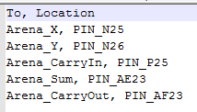

Figure 8: Pin Assignment for 2to1 Mux

There is 3 input switches used and 2 output LEDs. Before showing the 1-bit Full Adder, below in Figure **9** is my symbol I created for a 1-bit Half Adder.

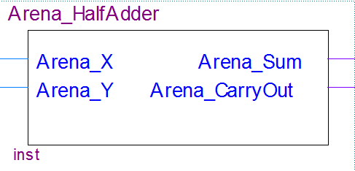

Figure 9: 1-bit Half Adder Symbol

Below in Figure **10** is the 1-bit Full Adder using Half Adders.

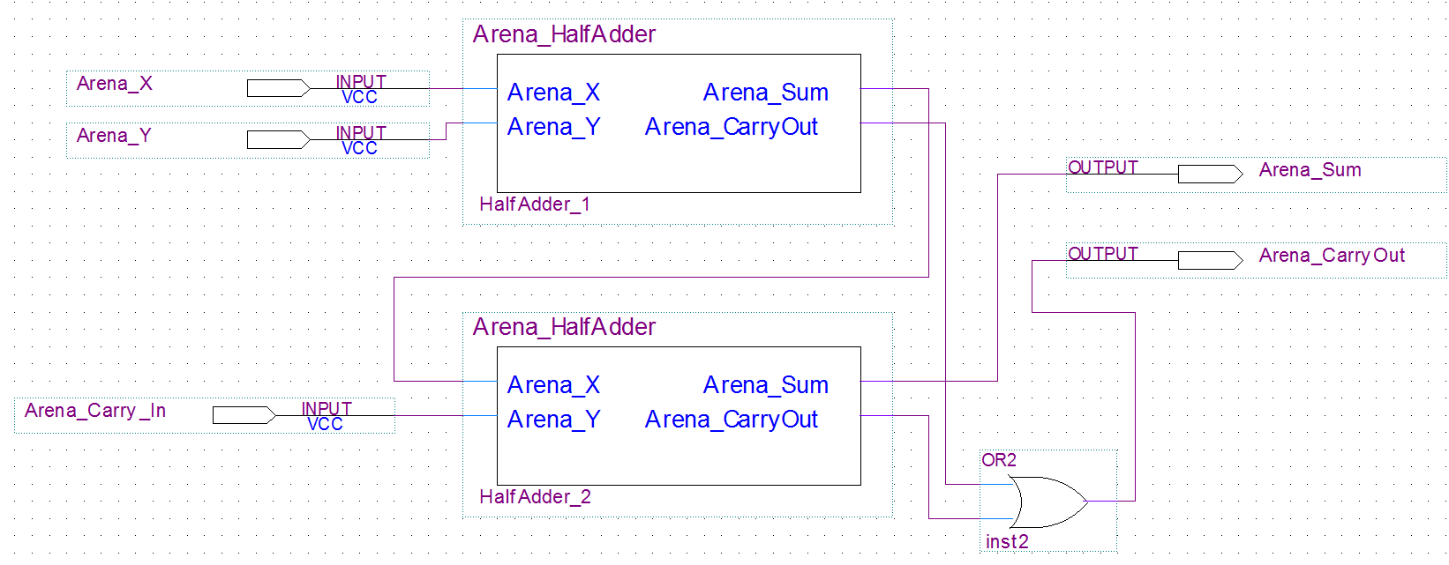

Figure 10: 1-bit Full Adder

As seen in the figure, there are two half adder’s cascaded together.

Looking at Arena_X for Half Adder 2, it takes in the output of the Sum in Half Adder 1, which is **X xor Y**. Arena_Y for Half Adder 1 takes in the CarryIn input. Knowing the design of the half adders from **Fig 6**, Arena_Sum for Half Adder 2 will be **Sum = Ci xor (X xor Y).**

Since for the CarryOut of Half Adder 2 is $Carry Out=Ci\left(X xor Y\right)+(XY)$**,** we know that the CarryOut of Half Adder 1 is (**XY**), so this can be plugged into an OR gate with the output of the Carryout of Half Adder 2, which gives us the final CarryOut of the Full Adder.

On the next page in figure **11** is the VHDL code I created for the 1-bit Full Adder.

-- (First, Last) John Arena - CSC 342/343 - Lab 1 - Spring 2019 Due: 2/20/19

-- Arena_FullAdder.vhd

**library** ieee**;**

**use** ieee**.**std_logic_1164**.all;**

**entity** Arena_FullAdder **is**

**port(**

Arena_X**,** Arena_Y**,** Arena_CarryIn **:** **in** std_logic**;** -- Three inputs, X, Y and CarryIn

Arena_Sum**,** Arena_CarryOut **:** **out** std_logic -- Two outputs, Sum and CarryOut

**);**

**end** Arena_FullAdder**;** -- End of entity

**architecture** Arena_Arch_FullAdder **of** Arena_FullAdder **is** -- Architecture describing functionality

**signal** Arena_Sum1**,** Arena_CarryOut1**,** Arena_CarryOut2 **:** std_logic**;** --Variables for mapping

**component** Arena_HalfAdder -- Using Half Adder component

**port(**

Arena_X**,** Arena_Y **:** **in** std_logic**;**

Arena_Sum**,** Arena_CarryOut **:** **out** std_logic

**);**

**end** **component;**

**begin**

HA1**:** Arena_HalfAdder **port** **map** **(**Arena_X**,** Arena_Y**,** Arena_Sum1**,** Arena_CarryOut1**);**

-- X into X, Y into Y, Sum1 out of Sum1, Co1 out of Co1

HA2**:** Arena_HalfAdder **port** **map(**Arena_Sum1**,** Arena_CarryIn**,** Arena_Sum**,** Arena_CarryOut2**);**

-- Sum1 into X, Ci into Y, Sum out as final Sum, CarryOut2 out of CarryOut2

Arena_CarryOut **<=** Arena_CarryOut1 or Arena_CarryOut2**;** -- Final CarryOut

--Sum is already final, don't need a statement

**end** Arena_Arch_FullAdder**;** -- end of architecture

Figure 11: 1-bit Full Adder VHDL Code

3to8 Decoder

The fourth circuit I will be designing is a **3 to 8 Decoder.**  A decoder, also known as a binary decoder, “is a device that, when activated, selects one of several output lines, based on a coded input signal. Most commonly, the input is an n-bit binary number, and there are up to 2^n output lines.” “The inputs are treated as a binary number, and the output selected is made active”. There are two forms of decoders. One is called *active high*, and one is called *active low.* Active high means an active output is 1 and an inactive output is 0. Active low is the opposite, where an active output is 0 and an inactive output is 1. For my design, I will be using an active high.

As the name states, this is a 3to8 decoder, meaning a 3 bit number to 8 corresponding output lines. As the definition even said, with n=3, 2^3 = 8. With that said, I came up with the truth table in table **5** below. The 3 inputs shall be denoted **A, B, C** and the outputs as **F0, F1…F7** for a total of 8.

|  |  |  |  |  |  |  |  |  |  |  |
| --- | --- | --- | --- | --- | --- | --- | --- | --- | --- | --- |
| **A** | **B** | **C** | **F0** | **F1** | **F2** | **F3** | **F4** | **F5** | **F6** | **F7** |
| **0** | **0** | **0** | **1** | **0** | **0** | **0** | **0** | **0** | **0** | **0** |
| **0** | **0** | **1** | **0** | **1** | **0** | **0** | **0** | **0** | **0** | **0** |
| **0** | **1** | **0** | **0** | **0** | **1** | **0** | **0** | **0** | **0** | **0** |
| **0** | **1** | **1** | **0** | **0** | **0** | **1** | **0** | **0** | **0** | **0** |
| **1** | **0** | **0** | **0** | **0** | **0** | **0** | **1** | **0** | **0** | **0** |
| **1** | **0** | **1** | **0** | **0** | **0** | **0** | **0** | **1** | **0** | **0** |
| **1** | **1** | **0** | **0** | **0** | **0** | **0** | **0** | **0** | **1** | **0** |
| **1** | **1** | **1** | **0** | **0** | **0** | **0** | **0** | **0** | **0** | **1** |

Table 5: 3to8 Decoder Truth Table

We can derive the Boolean algebra expression of each active high. They are as follows $$F0=A^{'}B^{'}C^{'}, F1=A^{'}B^{'}C, F2=A^{'}BC^{'}, F3=A^{'}BC \\ F4=AB^{'}C^{'} F5=AB^{'}C F6=ABC^{'} F7=ABC$$

Looking at these equations, it can be seen these are all 3 input AND gates with NOT gates. So the design will consist of 8 three-input AND gates and 3 NOT gates.

The inputs and outputs will be assigned as follows on our board, seen in Figure **12** below. It comes from the pin assignment text file for this circuit seen below in Figure **12**.

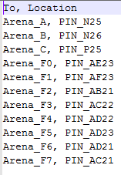

Figure 12: Pin Assignment for 2to1 Mux

There is 3 input switches used and 8 output LEDs. On the next page in figure **13** is the design of the circuit.

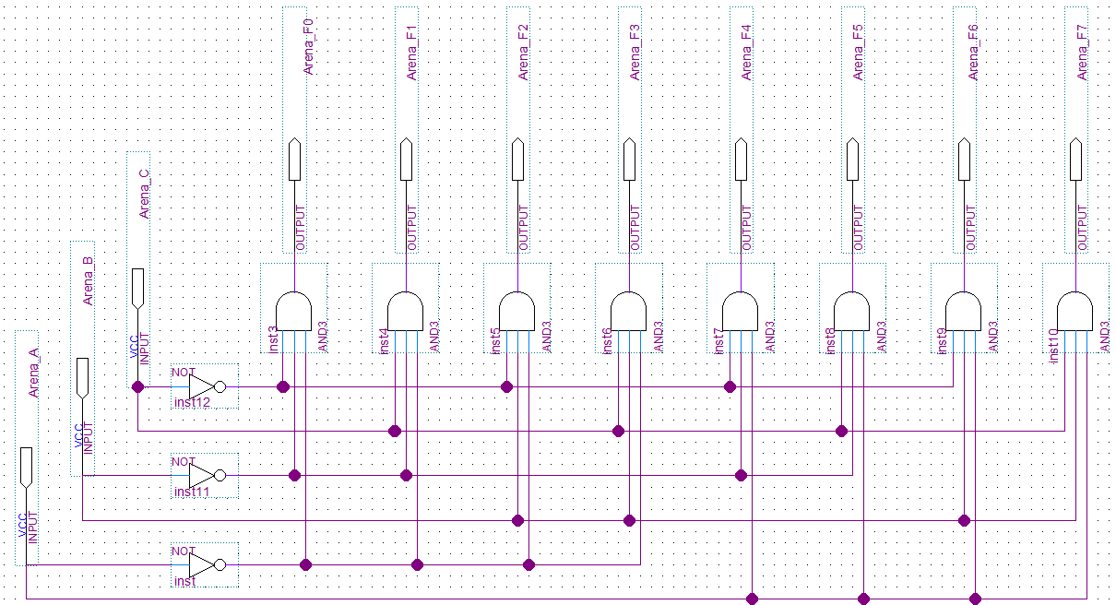

Figure 23: 3to8 Decoder Gate Level

Below in figure **14** is the VHDL code I created for the 3to8 Decoder.

-- (First, Last) John Arena - CSC 342/343 - Lab 1 - Spring 2019 Due: 2/20/19

-- Arena_3to8Decoder.vhd

**library** ieee**;**

**use** ieee**.**std_logic_1164**.all;**

**entity** Arena_3to8Decoder **is** -- Decoder entity

**port(**

Arena_A**,** Arena_B**,** Arena_C **:** **in** std_logic**;** -- 3 inputs, A B and C

Arena_F0**,** Arena_F1**,** Arena_F2 **:** **out** std_logic**;** -- 8 outputs, F0..F7

Arena_F3**,** Arena_F4**,** Arena_F5 **:** **out** std_logic**;**

Arena_F6**,** Arena_F7 **:** **out** std_logic -- all the way up to F7

**);**

**end** Arena_3to8Decoder**;** -- end of entity

**architecture** Arena_Arch_3to8Decoder **of** Arena_3to8Decoder **is** -- Architecture of Decoder, describing functionality

**begin**

Arena_F0 **<=** '1' **when** **(**Arena_A **=** '0' and Arena_B **=** '0' and Arena_C **=** '0'**)** **else** '0'**;** -- Set high when appropriate

Arena_F1 **<=** '1' **when** **(**Arena_A **=** '0' and Arena_B **=** '0' and Arena_C **=** '1'**)** **else** '0'**;** -- Otherwise 0

Arena_F2 **<=** '1' **when** **(**Arena_A **=** '0' and Arena_B **=** '1' and Arena_C **=** '0'**)** **else** '0'**;**

Arena_F3 **<=** '1' **when** **(**Arena_A **=** '0' and Arena_B **=** '1' and Arena_C **=** '1'**)** **else** '0'**;**

Arena_F4 **<=** '1' **when** **(**Arena_A **=** '1' and Arena_B **=** '0' and Arena_C **=** '0'**)** **else** '0'**;**

Arena_F5 **<=** '1' **when** **(**Arena_A **=** '1' and Arena_B **=** '0' and Arena_C **=** '1'**)** **else** '0'**;**

Arena_F6 **<=** '1' **when** **(**Arena_A **=** '1' and Arena_B **=** '1' and Arena_C **=** '0'**)** **else** '0'**;**

Arena_F7 **<=** '1' **when** **(**Arena_A **=** '1' and Arena_B **=** '1' and Arena_C **=** '1'**)** **else** '0'**;**

**end** Arena_Arch_3to8Decoder**;** -- end of architecture

Figure 34: 3to8 Decoder VHDL code

8to3 Encoder

The fifth and final circuit I will be designing is a **8 to 3 Encoder.**  A decoder, also known as a *binary encoder* is essentially the inverse of a binary decoder. So essentially whatever is active high (assuming this is an active high encoder), it will produce a 3-bit binary number output. “It is useful when one of several devices may be signaling a computer (by putting a 1 on a wire from that device); the encoder then produces the device number).” For my design, I will be using an active high.

As the name states, this is a 8to3 Encoder, meaning an 8-bit input to a 3-bit output.. We know a 3-bit number has 2^3=8 numbers, 0-7, so we need 8 states, so 8 possible inputs. With that said, I came up with the truth table in table **6** below. The 8 inputs shall be denoted **Y0, Y1…Y7** and the output as **A, B and C.**

|  |  |  |  |  |  |  |  |  |  |  |
| --- | --- | --- | --- | --- | --- | --- | --- | --- | --- | --- |
| **Y0** | **Y1** | **Y2** | **Y3** | **Y4** | **Y5** | **Y6** | **Y7** | **F0** | **F1** | **F2** |
| **0** | **0** | **0** | **0** | **0** | **0** | **0** | **1** | **0** | **0** | **0** |
| **0** | **0** | **0** | **0** | **0** | **0** | **1** | **0** | **0** | **0** | **1** |
| **0** | **0** | **0** | **0** | **0** | **1** | **0** | **0** | **0** | **1** | **0** |
| **0** | **0** | **0** | **0** | **1** | **0** | **0** | **0** | **0** | **1** | **1** |
| **0** | **0** | **0** | **1** | **0** | **0** | **0** | **0** | **1** | **0** | **0** |
| **0** | **0** | **1** | **0** | **0** | **0** | **0** | **0** | **1** | **0** | **1** |
| **0** | **1** | **0** | **0** | **0** | **0** | **0** | **0** | **1** | **1** | **0** |
| **1** | **0** | **0** | **0** | **0** | **0** | **0** | **0** | **1** | **1** | **1** |

Table6: 8to3 Encoder Truth Table

We can derive the Boolean algebra expression of each output. They are as follows $$F0=Y3+Y2+Y1+Y0 \\ F1=Y5+Y4+Y1+Y0 \\ F2=Y6+Y4+Y2+Y0$$

Looking at these equations, it can be seen these are all 4 input OR gates. The design will consist of 3 OR gates.

The inputs and outputs will be assigned as follows on our board, seen in Figure **15** below. It comes from the pin assignment text file for this circuit seen below in Figure **15.**

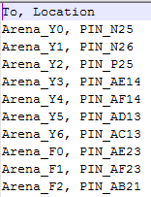

Figure 45: Pin Assignment for 8to3 Encoder

There is 8 input switches used and 3 output LEDs. On the next page in figure **16** is the design of the circuit.

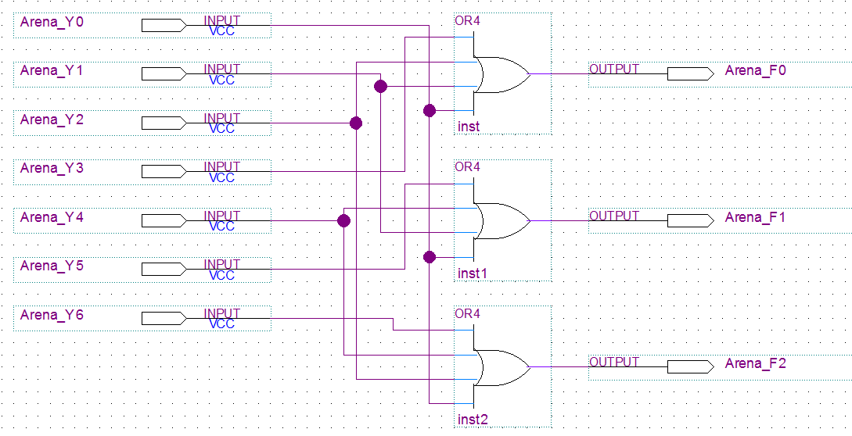

Figure 16: 8to3 Encoder at Gate Level

Below in figure **17** is the VHDL code I created for the 8to3 Encoder.

-- (First, Last) John Arena - CSC 342/343 - Lab 1 - Spring 2019 Due: 2/20/19

-- Arena_3to8Decoder.vhd

**library** ieee**;**

**use** ieee**.**std_logic_1164**.all;**

**entity** Arena_8to3Encoder **is** -- Entity for Encoder

**port(**

Arena_Y0**,** Arena_Y1**,** Arena_Y2**,** Arena_Y3 **:** **in** std_logic**;** -- 8 inputs

Arena_Y4**,** Arena_Y5**,** Arena_Y6**,** Arena_Y7 **:** **in** std_logic**;**

Arena_F0**,** Arena_F1**,** Arena_F2 **:** **out** std_logic -- 3 outputs

**);**

**end** Arena_8to3Encoder**;** -- End of entity

**architecture** Arena_Arch_8to3Encoder **of** Arena_8to3Encoder **is** --Architecture to describe functionality

**begin**

Arena_F0 **<=** **(**Arena_Y3 or Arena_Y2 or Arena_Y1 or Arena_Y0**);** -- F0 = Y3+Y2+Y1+Y0

Arena_F1 **<=** **(**Arena_Y5 or Arena_Y4 or Arena_Y1 or Arena_Y0**);** -- F1 = Y5+Y4+Y1+Y0

Arena_F2 **<=** **(**Arena_Y6 or Arena_Y4 or Arena_Y2 or Arena_Y0**);** -- F2 = Y6+Y4+Y2+Y0

**end** Arena_Arch_8to3Encoder**;** -- End of architecture

Figure 57: 8to3 Encoder VHDL code

**Section 3) Simulations**

2to1 Multiplexer

The first simulation will be done for the 2to1 Multiplexer. Figure **18** below is shows the testbench code for the multiplexer.

-- (First, Last) John Arena - CSC 342/343 - Lab 1 - Spring 2019 Due: 2/20/19

-- Arena_mux2to1_tb.vhd

**library** ieee**;**

**use** ieee**.**std_logic_1164**.all;**

**Entity** Arena_mux2to1_tb **is**

**end** Arena_mux2to1_tb**;**

**Architecture** Arena_Arch_mux2to1_tb **of** Arena_mux2to1_tb **is**

**signal** Arena_X**,** Arena_Y**,** Arena_S **:** std_logic**;**

**signal** Arena_M **:** std_logic**;**

-- declare record type

**type** test_vector **is** **record**

Arena_X**,** Arena_Y**,** Arena_S **:** std_logic**;**

Arena_M **:** std_logic**;**

**end** **record;**

**type** test_vector_array **is** **array** **(**natural **range** **<>)** **of** test_vector**;**

**constant** test_vectors **:** test_vector_array **:=** **(**

-- Arena_X, Arena_Y, Arena_S, Arena_M -- positional method is used below

**(**'0'**,** '0'**,** '0'**,** '0'**),** -- or (X => '0', Y => '0', S => '0', M => '0')

**(**'0'**,** '0'**,** '1'**,** '0'**),**

**(**'0'**,** '1'**,** '0'**,** '0'**),**

**(**'0'**,** '1'**,** '1'**,** '1'**),**

**(**'1'**,** '0'**,** '0'**,** '1'**),**

**(**'1'**,** '0'**,** '1'**,** '0'**),**

**(**'1'**,** '1'**,** '0'**,** '1'**),**

**(**'1'**,** '1'**,** '1'**,** '1'**)**

**);**

**begin**

UUT**:** **entity** work**.**Arena_mux2to1 **port** **map** **(**Arena_X **=>** Arena_X**,** Arena_Y **=>** Arena_Y**,** Arena_S **=>** Arena_S**,** Arena_M **=>** Arena_M**);**

tb1**:** **process**

**begin**

**for** i **in** test_vectors'**range** **loop**

Arena_X **<=** test_vectors**(**i**).**Arena_X**;** -- signal a = i^th-row-value of test_vector's a

Arena_Y **<=** test_vectors**(**i**).**Arena_Y**;** -- row left to right

Arena_S **<=** test_vectors**(**i**).**Arena_S**;**

Arena_M **<=** test_vectors**(**i**).**Arena_M**;**

**wait** **for** 20 ns**;**

**assert** **(**

**(**Arena_X **=** test_vectors**(**i**).**Arena_X**)** **and**

**(**Arena_Y **=** test_vectors**(**i**).**Arena_Y**)** **and**

**(**Arena_S **=** test_vectors**(**i**).**Arena_S**)** **and**

**(**Arena_M **=** test_vectors**(**i**).**Arena_M**)**

**)**

-- image is used for string-representation of integer etc.

**report** "test_vector " **&** integer'**image(**i**)** **&** " failed " **&** --T'image(x) is a string represesntation of x of type T

" for input Arena_X = " **&** std_logic'**image(**Arena_X**)** **&**

" and Arena_Y = " **&** std_logic'**image(**Arena_Y**)** **&**

" and Arena_S = " **&** std_logic'**image(**Arena_S**)** **&**

" for output Arena_M = " **&** std_logic'**image(**Arena_M**)**

**severity** error**;**

**end** **loop;**

**wait;**

**end** **process;**

**end** Arena_Arch_mux2to1_tb**;**

Figure 68: 2to1 Mux VHDL TB Code

Our results should correspond with the truth table in Table **1**. Below in Figure **19** is the results from the Waveform file.  
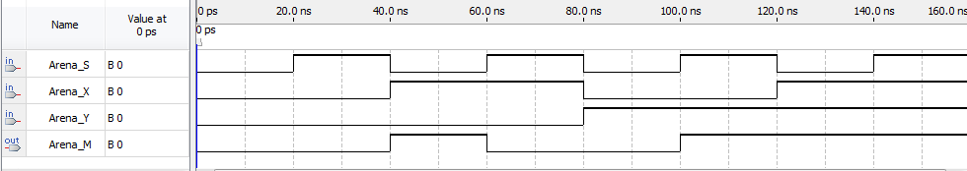

Figure 19: 2to1 Mux Waveform

Below in Figure **20** is the results from the testbench file.



Figure 20: 2to1 Mux Testbench

Below in figure **21** is the output from the console for the testbench.



Figure 7: 2to1 Mux Testbench Console Output

Looking at the figures above, we can see our design for the 2to1 Multiplexer is correct. The easiest way to see this is from the output from the console. After running the whole testbench, it finished with no output. We know from the assert statement at the top of the page will only print an error message if the equality in the assert statement was found to be false. Another way to see it’s correct is comparing the Waveform and the Testbench to the truth table. We know whenever Arena_S = 0, the output Arena_M = X. Looking at 000 for example, we see Arena_X=0, and Arena_S=0, so the output Arena_M = 0. This can be seen for all those cases. For Arena_S = 1, we see the output Arena_M = Y, which is what our truth table states, proving our design is correct.

1-bit Half Adder

The second simulation will be done for the 1-bit Half Adder. Figure **22** below is shows the testbench code for the half adder.

-- (First, Last) John Arena - CSC 342/343 - Lab 1 - Spring 2019 Due: 2/20/19

-- Arena_HalfAdder_tb.vhd

**library** ieee**;**

**use** ieee**.**std_logic_1164**.all;**

**Entity** Arena_HalfAdder_tb **is**

**end** Arena_HalfAdder_tb**;**

**Architecture** Arena_Arch_HalfAdder_tb **of** Arena_HalfAdder_tb **is** -- Describiing functionality

**signal** Arena_X**,** Arena_Y **:** std_logic**;**

**signal** Arena_CarryOut**,** Arena_Sum **:** std_logic**;**

**begin**

-- connecting testbench signals with Arena_HalfAdder.vhd

UUT **:** **entity** work**.**Arena_HalfAdder **port** **map** **(**Arena_X **=>** Arena_X**,** Arena_Y **=>** Arena_Y**,** Arena_CarryOut **=>** Arena_CarryOut**,** Arena_Sum **=>** Arena_Sum**);**

tb1**:** **process**

**constant** period**:** time **:=** 40ns**;**

**begin**

Arena_X **<=** '0'**;**

Arena_Y **<=** '0'**;**

**wait** **for** period**;**

**assert((**Arena_Sum **=**'0'**)** **and** **(**Arena_CarryOut **=** '0'**))** -- expected output

-- error reported below if the sum or carry is not 0

**report** "Test failed for input combination 00" **severity** error**;**

Arena_X **<=** '0'**;**

Arena_Y **<=** '1'**;**

**wait** **for** period**;**

**assert((**Arena_Sum **=**'1'**)** **and** **(**Arena_CarryOut **=** '0'**))** -- expected output

-- error reported below if the sum or carry is not 0

**report** "Test failed for input combination 01" **severity** error**;**

Arena_X **<=** '1'**;**

Arena_Y **<=** '0'**;**

**wait** **for** period**;**

**assert((**Arena_Sum **=**'1'**)** **and** **(**Arena_CarryOut **=** '0'**))** -- expected output

-- error reported below if the sum or carry is not 0

**report** "Test failed for input combination 10" **severity** error**;**

Arena_X **<=** '1'**;**

Arena_Y **<=** '1'**;**

**wait** **for** period**;**

**assert((**Arena_Sum **=**'0'**)** **and** **(**Arena_CarryOut **=** '1'**))** -- expected output

-- error reported below if the sum or carry is not 0

**report** "Test failed for input combination 11" **severity** error**;**

**wait;**

**end** **process;**

**end** Arena_Arch_HalfAdder_tb**;**

Figure 228: 1-bit Half Adder VHDL TB Code

Our results should correspond with the truth table in Table **2**. Below in Figure **23** is the results from the Waveform file.  
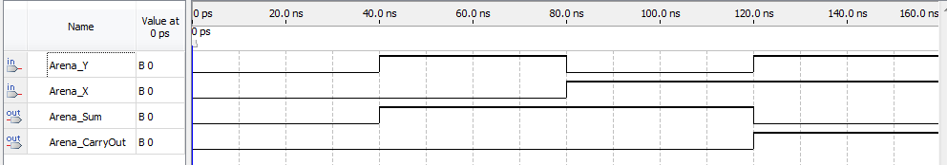

Figure 23: 1-bit Half Adder Waveform

Below in Figure **24** is the results from the testbench file. In this testbench, it actually compares the actual half adder VHDL file to the testbench results. The testbench are the last four waves, denoted with a UUT on the left side, which stands for **Unit Under Test.**

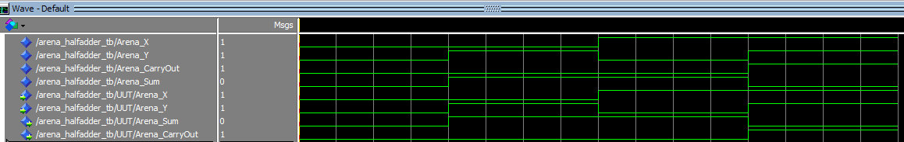

Figure 24: 1-bit Half Adder Testbench

Below in figure **25** is the output from the console for the testbench.

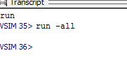

Figure25: 1-bit Half Adder Console Output

Looking at the figures above, we can see our design for 1-bit Half Adder is correct. The easiest way to see this is from the output from the console. After running the whole testbench, it finished with no output. We know from the various assert statements in figure **25** will only print an error message if the equality in the assert statement was found to be false. Another way to see it’s correct is comparing the Waveform and the Testbench to the truth table. We can see in the figures whenever Arena_X != Arena_Y, then Arena_Sum = 1, otherwise 0, and when Arena_X=Arena_Y, Arena_CarryOut = 1, otherwise 0, which is what our truth table states, proving our design is correct.

1-bit Full Adder

The third simulation will be done for the 1-bit Full Adder. Figure **26** below is shows the testbench code for the multiplexer.

-- Arena_FullAdder_tb.vhd

**library** ieee**;**

**use** ieee**.**std_logic_1164**.all;**

**Entity** Arena_FullAdder_tb **is**

**end** Arena_FullAdder_tb**;**

**Architecture** Arena_Arch_FullAdder_tb **of** Arena_FullAdder_tb **is**

**signal** Arena_X**,** Arena_Y**,** Arena_CarryIn **:** std_logic**;**

**signal** Arena_CarryOut**,** Arena_Sum **:** std_logic**;**

**type** test_vector **is** **record**

Arena_X**,** Arena_Y**,** Arena_CarryIn **:** std_logic**;**

Arena_CarryOut**,** Arena_Sum **:** std_logic**;**

**end** **record;**

**type** test_vector_array **is** **array** **(**natural **range** **<>** **)** **of** test_vector**;**

**constant** test_vectors **:** test_vector_array **:=** **(**

-- Arena_X, Arena_Y, Arena_CarryIn, Arena_CarryOut, Arena_Sum

**(**'0'**,** '0'**,** '0'**,** '0'**,** '0'**),** -- X=0,Y=0,Ci=0, Co=0,S=0

**(**'0'**,** '0'**,** '1'**,** '0'**,** '1'**),**

**(**'0'**,** '1'**,** '0'**,** '0'**,** '1'**),**

**(**'0'**,** '1'**,** '1'**,** '1'**,** '0'**),**

**(**'1'**,** '0'**,** '0'**,** '0'**,** '1'**),**

**(**'1'**,** '0'**,** '1'**,** '1'**,** '0'**),**

**(**'1'**,** '1'**,** '0'**,** '1'**,** '0'**),**

**(**'1'**,** '1'**,** '1'**,** '1'**,** '1'**),**

**(**'0'**,** '0'**,** '1'**,** '1'**,** '0'**)** -- fail test

**);**

**begin**

-- connecting testbench signals with Arena_HalfAdder.vhd

UUT **:** **entity** work**.**Arena_FullAdder **port** **map** **(**Arena_X1 **=>** Arena_X**,** Arena_Y1 **=>** Arena_Y**,** Arena_CarryIn1 **=>** Arena_CarryIn**,** Arena_CarryOut **=>** Arena_CarryOut**,** Arena_Sum **=>** Arena_Sum**);**

tb1**:** **process**

**constant** period**:** time **:=** 40ns**;**

**begin**

**for** i **in** test_vectors'**range** **loop**

Arena_X **<=** test_vectors**(**i**).**Arena_X**;** -- signal a = i^th-row-value of test_vector's a

Arena_Y **<=** test_vectors**(**i**).**Arena_Y**;**

Arena_CarryIn **<=** test_vectors**(**i**).**Arena_CarryIn**;**

**wait** **for** period**;**

**assert(**

**(**Arena_CarryOut **=** test_vectors**(**i**).**Arena_CarryOut**)** **and**

**(**Arena_Sum **=** test_vectors**(**i**).**Arena_Sum**)**

**)**

**report**"test_vector " **&** integer'**image(**i**)** **&** " failed " **&** " for input Arena_X = " **&** std_logic'**image(**Arena_X**)** **&**

" and Arena_Y = " **&** std_logic'**image(**Arena_Y**)** **&**

" and Arena_CarryIn = " **&** std_logic'**image(**Arena_CarryIn**)** **&**

" For output Arena_CarryOut = " **&** std_logic'**image(**Arena_CarryOut**)** **&** " and output Arena_Sum = " **&** std_logic'**image(**Arena_Sum**)**

**severity** error**;**

**end** **loop;**

**wait;**

**end** **process;**

**end** Arena_Arch_FullAdder_tb**;**

Figure 269: 1-bit Full Adder VHDL TB Code

The interesting thing about this testbench file is it uses an array of numbers and a for loop to go through them. There are 9 tests in the array for the for loop to go through. If there was no for loop, there would be 9 assert and report statements, which is very messy and confusing.

Our results should correspond with the truth table in Table **3**. Below in Figure **27**is the results from the Waveform file.  
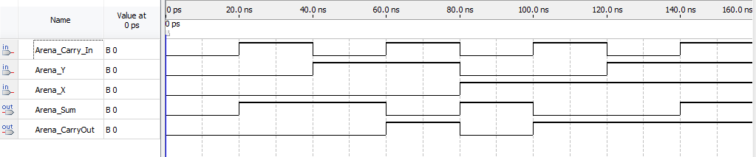

Figure 27: 1-bit Full Adder Waveform

Below in Figure **28** is the results from the testbench file. In this testbench, similar to the last one, it compares the actual full adder VHDL file to the testbench results. The testbench are the last five waves, denoted with a UUT on the left side, which stands for **Unit Under Test.**

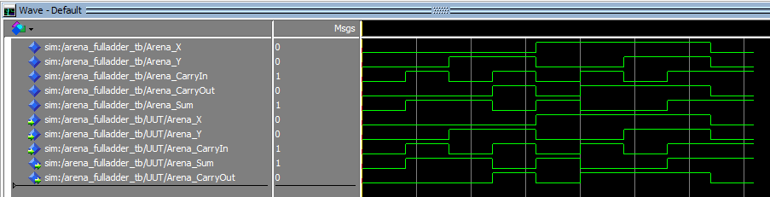

Figure 2810: 1-bit Half Adder Testbench

Below in figure **29** is the output from the console for the testbench.



Figure 29: 1-bit Full Adder Console Output

Looking at the figures above, we can see our design for 1-bit Full Adder is correct. The easiest way to see this is from the output from the console. After running the whole testbench, it finished with 1 error message. This is different compared to our last two simulations, but is this a problem? Let’s take a look at the message. It says for Inputs **X=0, Y=0, CarryIn=1 and outputs CarryOut=0 and Sum = 1, vector(8) failed.** Looking back at the code, vector(8) is as follows:

**(**'0'**,** '0'**,** '1'**,** '1'**,** '0'**)** -- fail test for verification

This has **X=0, Y=0, Ci=1, Co=1, S=0.** Notice that this actually doesn’t make sense. Looking back on page 9, if a 0 and 1 is added, the resulting sum should be 1 with a carry of 0. Here it says a carry of 1 wit ha sum of 0, which is incorrect. So if the assert statement failed on an incorrect test, that means the Full Adder actually behaved as it should! Also, seeing this is the only fail test verification for this testbench, and there was no other output to the console, the testbench passed. Another way to see it’s correct is comparing the Waveform and the Testbench to the truth table. We can see in the figures that the results compared to the truth table are correct, thus confirming our design is correct.

3to8 Decoder

The fourth simulation will be done for the 3to8Decoder. Figure **30** below is shows the testbench code for the multiplexer.

-- (First, Last) John Arena - CSC 342/343 - Lab 1 - Spring 2019 Due: 2/20/19

-- Arena_3to8Decoder_tb.vhd

**library** ieee**;**

**use** ieee**.**std_logic_1164**.all;**

**Entity** Arena_3to8Decoder_tb **is**

**end** Arena_3to8Decoder_tb**;**

**Architecture** Arena_Arch_3to8Decoder_tb **of** Arena_3to8Decoder_tb **is**

**signal** Arena_A**,** Arena_B**,** Arena_C **:** std_logic**;** -- Defining signals

**signal** Arena_F0**,** Arena_F1**,** Arena_F2 **:** std_logic**;**

**signal** Arena_F3**,** Arena_F4**,** Arena_F5 **:** std_logic**;**

**signal** Arena_F6**,** Arena_F7 **:** std_logic**;**

**type** test_vector **is** **record** -- collection of signals in one object, like C structures

Arena_A**,** Arena_B**,** Arena_C **:** std_logic**;**

Arena_F0**,** Arena_F1**,** Arena_F2 **:** std_logic**;**

Arena_F3**,** Arena_F4**,** Arena_F5 **:** std_logic**;**

Arena_F6**,** Arena_F7 **:** std_logic**;**

**end** **record;**

**type** test_vector_array **is** **array** **(**natural **range** **<>** **)** **of** test_vector**;** -- Array of test_vector

**constant** test_vectors **:** test_vector_array **:=** **(**

-- Arena_A, Arena_B, Arena_C, Arena_F0, Arena_F1, Arena_F2, Arena_F3, Arena_F4, Arena_F5, Arena_F6, Arena_F7,

**(**'0'**,** '0'**,** '0'**,** '1'**,** '0'**,** '0'**,** '0'**,** '0'**,** '0'**,** '0'**,** '0'**),** -- A=0,B=0,C=0,F0=0...F7=0

**(**'0'**,** '0'**,** '1'**,** '0'**,** '1'**,** '0'**,** '0'**,** '0'**,** '0'**,** '0'**,** '0'**),**

**(**'0'**,** '1'**,** '0'**,** '0'**,** '0'**,** '1'**,** '0'**,** '0'**,** '0'**,** '0'**,** '0'**),**

**(**'0'**,** '1'**,** '1'**,** '0'**,** '0'**,** '0'**,** '1'**,** '0'**,** '0'**,** '0'**,** '0'**),**

**(**'1'**,** '0'**,** '0'**,** '0'**,** '0'**,** '0'**,** '0'**,** '1'**,** '0'**,** '0'**,** '0'**),**

**(**'1'**,** '0'**,** '1'**,** '0'**,** '0'**,** '0'**,** '0'**,** '0'**,** '1'**,** '0'**,** '0'**),**

**(**'1'**,** '1'**,** '0'**,** '0'**,** '0'**,** '0'**,** '0'**,** '0'**,** '0'**,** '1'**,** '0'**),**

**(**'1'**,** '1'**,** '1'**,** '0'**,** '0'**,** '0'**,** '0'**,** '0'**,** '0'**,** '0'**,** '1'**)**

**);**

**begin**

-- connecting testbench signals with Arena_3to8Decoder.vhd

UUT **:** **entity** work**.**Arena_3to8Decoder **port** **map** **(**Arena_A **=>** Arena_A**,** Arena_B **=>** Arena_B**,** Arena_C **=>** Arena_C**,** Arena_F0 **=>** Arena_F0**,** Arena_F1 **=>** Arena_F1**,**

Arena_F2 **=>** Arena_F2**,** Arena_F3 **=>** Arena_F3**,** Arena_F4 **=>** Arena_F4**,** Arena_F5 **=>** Arena_F5**,** Arena_F6 **=>** Arena_F6**,** Arena_F7 **=>** Arena_F7**);**

tb1**:** **process**

**constant** period**:** time **:=** 40ns**;**

**begin**

**for** i **in** test_vectors'**range** **loop**

Arena_A **<=** test_vectors**(**i**).**Arena_A**;** -- signal a = i^th-row-value of test_vector's a

Arena_B **<=** test_vectors**(**i**).**Arena_B**;** -- row is left to right

Arena_C **<=** test_vectors**(**i**).**Arena_C**;**

Arena_F0 **<=** test_vectors**(**i**).**Arena_F0**;**

Arena_F1 **<=** test_vectors**(**i**).**Arena_F1**;**

Arena_F2 **<=** test_vectors**(**i**).**Arena_F2**;**

Arena_F3 **<=** test_vectors**(**i**).**Arena_F3**;**

Arena_F4 **<=** test_vectors**(**i**).**Arena_F4**;**

Arena_F5 **<=** test_vectors**(**i**).**Arena_F5**;**

Arena_F6 **<=** test_vectors**(**i**).**Arena_F6**;**

Arena_F7 **<=** test_vectors**(**i**).**Arena_F7**;**

**wait** **for** period**;**

**assert(**

**(**Arena_A **<=** test_vectors**(**i**).**Arena_A**)** **and**

**(**Arena_B **<=** test_vectors**(**i**).**Arena_B**)** **and**

**(**Arena_C **<=** test_vectors**(**i**).**Arena_C**)** **and**

**(**Arena_F0 **<=** test_vectors**(**i**).**Arena_F0**)** **and**

**(**Arena_F1 **<=** test_vectors**(**i**).**Arena_F1**)** **and**

**(**Arena_F2 **<=** test_vectors**(**i**).**Arena_F2**)** **and**

**(**Arena_F3 **<=** test_vectors**(**i**).**Arena_F3**)** **and**

**(**Arena_F4 **<=** test_vectors**(**i**).**Arena_F4**)** **and**

**(**Arena_F5 **<=** test_vectors**(**i**).**Arena_F5**)** **and**

**(**Arena_F6 **<=** test_vectors**(**i**).**Arena_F6**)** **and**

**(**Arena_F7 **<=** test_vectors**(**i**).**Arena_F7**)**

**)**

**report**"test_vector " **&** integer'**image(**i**)** **&** " failed " **&**

" for input Arena_A = " **&** std_logic'**image(**Arena_A**)** **&**

" and Arena_B = " **&** std_logic'**image(**Arena_B**)** **&**

" and Arena_C = " **&** std_logic'**image(**Arena_C**)** **&**

" For output Arena_F0 = " **&** std_logic'**image(**Arena_F0**)** **&**

" and output Arena_F1 = " **&** std_logic'**image(**Arena_F1**)** **&**

" and output Arena_F2 = " **&** std_logic'**image(**Arena_F2**)** **&**

" and output Arena_F3 = " **&** std_logic'**image(**Arena_F3**)** **&**

" and output Arena_F4 = " **&** std_logic'**image(**Arena_F4**)** **&**

" and output Arena_F5 = " **&** std_logic'**image(**Arena_F5**)** **&**

" and output Arena_F6 = " **&** std_logic'**image(**Arena_F6**)** **&**

" and output Arena_F7 = " **&** std_logic'**image(**Arena_F7**)**

**severity** error**;**

**end** **loop;**

**wait;**

**end** **process;**

**end** Arena_Arch_3to8Decoder_tb**;**

Figure 11: 3to8 Decoder VHDL TB Code

As like the testbench file for the full adder, this testbench file uses an array of numbers and a for loop to go through them. There are 8 tests in the array for the for loop to go through. If there was no for loop, there would be 8 assert and report statements, which is very messy and confusing.

The results should correspond with the truth table in Table **4**. Below in Figure **31** is the results from the Waveform file.  
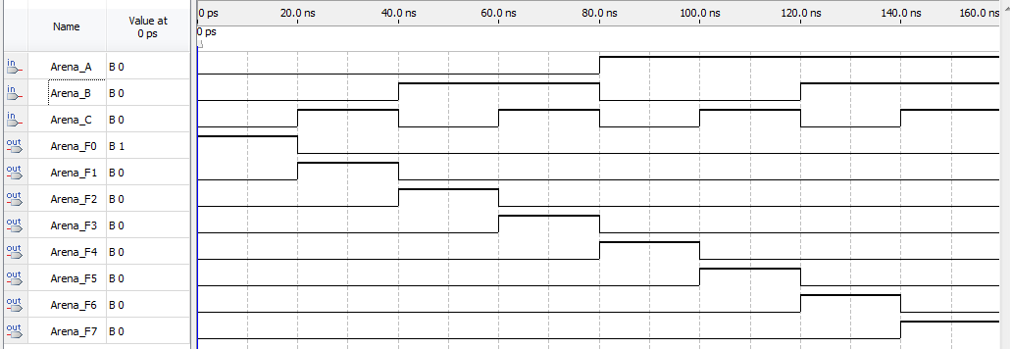

Figure 31: 3to8 Decoder Waveform

Below in Figure **32** is the results from the testbench file. In this testbench, unlike the last two, I did not include the comparison to the actual 3to8 decoder file, the reason being is the waveforms were too small to be seen properly. In doing so, I left the ones denoted with a UUT on the left side, which stands for **Unit Under Test,** which is the testbench testing the 3to8 decoder.

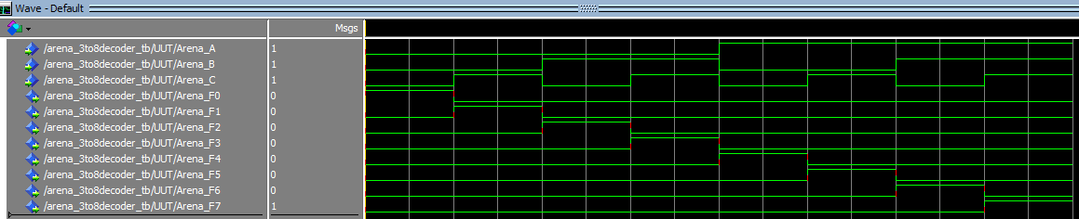

Figure 32: 1-bit Half Adder Testbench

Below in figure **33** is the output from the console for the testbench.



Figure 33: 3to8 Decoder Console Output

Looking at the figures above, we can see the design for 3to8 Decoder is correct. The easiest way to see this is from the output from the console. After running the whole testbench, it finished with no error message. In this test, there was no fail test included, but can be added if wanted.

With that said, there was no output to the console, the testbench passed. Another way to see it’s correct is comparing the Waveform and the Testbench to the truth table. We can see in the figures that the results compared to the truth table are correct, thus confirming our design is correct.

8to3 Encoder

The fifth and final simulation will be done for the 8to3 Encoder. Figure **34** below is shows the testbench code for the 8to3 Encoder.

-- (First, Last) John Arena - CSC 342/343 - Lab 1 - Spring 2019 Due: 2/20/19

-- Arena_8to3Encoder_tb.vhd

**library** ieee**;**

**use** ieee**.**std_logic_1164**.all;**

**Entity** Arena_8to3Encoder_tb **is**

**end** Arena_8to3Encoder_tb**;**

**Architecture** Arena_Arch_8to3Encoder_tb **of** Arena_8to3Encoder_tb **is**

**signal** Arena_Y0**,** Arena_Y1**,** Arena_Y2 **:** std_logic**;** -- define signals

**signal** Arena_Y3**,** Arena_Y4**,** Arena_Y5 **:** std_logic**;**

**signal** Arena_Y6**,** Arena_Y7 **:** std_logic**;**

**signal** Arena_F0**,** Arena_F1**,** Arena_F2 **:** std_logic**;**

**type** test_vector **is** **record** -- collection of signals in one object, like C structures

Arena_Y0**,** Arena_Y1**,** Arena_Y2 **:** std_logic**;**

Arena_Y3**,** Arena_Y4**,** Arena_Y5 **:** std_logic**;**

Arena_Y6**,** Arena_Y7 **:** std_logic**;**

Arena_F0**,** Arena_F1**,** Arena_F2 **:** std_logic**;**

**end** **record;**

**type** test_vector_array **is** **array** **(**natural **range** **<>** **)** **of** test_vector**;** --Array of test vector

**constant** test_vectors **:** test_vector_array **:=** **(**

-- Arena_Y0, Arena_Y1, Arena_Y2, Arena_Y3, Arena_Y4, Arena_Y5, Arena_Y6, Arena_Y7, Arena_Y0, Arena_Y1, Arena_Y2,

**(**'0'**,** '0'**,** '0'**,** '0'**,** '0'**,** '0'**,** '0'**,** '1'**,** '0'**,** '0'**,** '0'**),** -- Y0=0...Y7=0,F0=0,F1=0,F2=0

**(**'0'**,** '0'**,** '0'**,** '0'**,** '0'**,** '0'**,** '1'**,** '0'**,** '0'**,** '0'**,** '1'**),**

**(**'0'**,** '0'**,** '0'**,** '0'**,** '0'**,** '1'**,** '0'**,** '0'**,** '0'**,** '1'**,** '0'**),**

**(**'0'**,** '0'**,** '0'**,** '0'**,** '1'**,** '0'**,** '0'**,** '0'**,** '0'**,** '1'**,** '1'**),**

**(**'0'**,** '0'**,** '0'**,** '1'**,** '0'**,** '0'**,** '0'**,** '0'**,** '1'**,** '0'**,** '0'**),**

**(**'0'**,** '0'**,** '1'**,** '0'**,** '0'**,** '0'**,** '0'**,** '0'**,** '1'**,** '0'**,** '1'**),**

**(**'0'**,** '1'**,** '0'**,** '0'**,** '0'**,** '0'**,** '0'**,** '0'**,** '1'**,** '1'**,** '0'**),**

**(**'1'**,** '0'**,** '0'**,** '0'**,** '0'**,** '0'**,** '0'**,** '0'**,** '1'**,** '1'**,** '1'**)**

--('0', '0', '1', '1', '0', '0', '0', '0', '0', '0', '1') -- fail test

**);**

**begin**

-- connecting testbench signals with Arena_8to3Encoder.vhd

UUT **:** **entity** work**.**Arena_8to3Encoder **port** **map** **(**Arena_F0 **=>** Arena_F0**,** Arena_F1 **=>** Arena_F1**,** Arena_F2 **=>** Arena_F2**,** Arena_Y0 **=>** Arena_Y0**,** Arena_Y1 **=>** Arena_Y1**,**

Arena_Y2 **=>** Arena_Y2**,** Arena_Y3 **=>** Arena_Y3**,** Arena_Y4 **=>** Arena_Y4**,** Arena_Y5 **=>** Arena_Y5**,** Arena_Y6 **=>** Arena_Y6**,** Arena_Y7 **=>** Arena_Y7**);**

tb1**:** **process**

**constant** period**:** time **:=** 40ns**;**

**begin**

**for** i **in** test_vectors'**range** **loop**

Arena_Y0 **<=** test_vectors**(**i**).**Arena_Y0**;** -- signal a = i^th-row-value of test_vector's a

Arena_Y1 **<=** test_vectors**(**i**).**Arena_Y1**;** -- row is left to right

Arena_Y2 **<=** test_vectors**(**i**).**Arena_Y2**;**

Arena_Y3 **<=** test_vectors**(**i**).**Arena_Y3**;**

Arena_Y4 **<=** test_vectors**(**i**).**Arena_Y4**;**

Arena_Y5 **<=** test_vectors**(**i**).**Arena_Y5**;**

Arena_Y6 **<=** test_vectors**(**i**).**Arena_Y6**;**

Arena_Y7 **<=** test_vectors**(**i**).**Arena_Y7**;**

Arena_F0 **<=** test_vectors**(**i**).**Arena_F0**;**

Arena_F1 **<=** test_vectors**(**i**).**Arena_F1**;**

Arena_F2 **<=** test_vectors**(**i**).**Arena_F2**;**

**wait** **for** period**;**

**assert(**

**(**Arena_Y0 **<=** test_vectors**(**i**).**Arena_Y0**)** **and**

**(**Arena_Y1 **<=** test_vectors**(**i**).**Arena_Y1**)** **and**

**(**Arena_Y2 **<=** test_vectors**(**i**).**Arena_Y2**)** **and**

**(**Arena_Y3 **<=** test_vectors**(**i**).**Arena_Y3**)** **and**

**(**Arena_Y4 **<=** test_vectors**(**i**).**Arena_Y4**)** **and**

**(**Arena_Y5 **<=** test_vectors**(**i**).**Arena_Y5**)** **and**

**(**Arena_Y6 **<=** test_vectors**(**i**).**Arena_Y6**)** **and**

**(**Arena_Y7 **<=** test_vectors**(**i**).**Arena_Y7**)** **and**

**(**Arena_F0 **<=** test_vectors**(**i**).**Arena_F0**)** **and**

**(**Arena_F1 **<=** test_vectors**(**i**).**Arena_F1**)** **and**

**(**Arena_F2 **<=** test_vectors**(**i**).**Arena_F2**)**

**)**

**report**"test_vector " **&** integer'**image(**i**)** **&** " failed " **&** --T'image(x) is a string represesntation of x of type T

" For input Arena_Y0 = " **&** std_logic'**image(**Arena_Y0**)** **&**

" and input Arena_Y1 = " **&** std_logic'**image(**Arena_Y1**)** **&**

" and input Arena_Y2 = " **&** std_logic'**image(**Arena_Y2**)** **&**

" and input Arena_Y3 = " **&** std_logic'**image(**Arena_Y3**)** **&**

" and input Arena_Y4 = " **&** std_logic'**image(**Arena_Y4**)** **&**

" and input Arena_Y5 = " **&** std_logic'**image(**Arena_Y5**)** **&**

" and input Arena_Y6 = " **&** std_logic'**image(**Arena_Y6**)** **&**

" and input Arena_Y7 = " **&** std_logic'**image(**Arena_Y7**)** **&**

" for output Arena_F0 = " **&** std_logic'**image(**Arena_F0**)** **&**

" and Arena_F1 = " **&** std_logic'**image(**Arena_F1**)** **&**

" and Arena_F2 = " **&** std_logic'**image(**Arena_F2**)**

**severity** error**;**

**end** **loop;**

**wait;**

**end** **process;**

**end** Arena_Arch_8to3Encoder_tb**;**

Figure 34: 8to3 Encoder VHDL TB Code

As like the testbench file for the full adder and the decoder, this testbench file uses an array of numbers and a for loop to go through them. There are 8 tests in the array for the for loop to go through. If there was no for loop, there would be 8 assert and report statements, which is very messy and confusing.

The results should correspond with the truth table in Table **5**. Below in Figure **35** is the results from the Waveform file.  
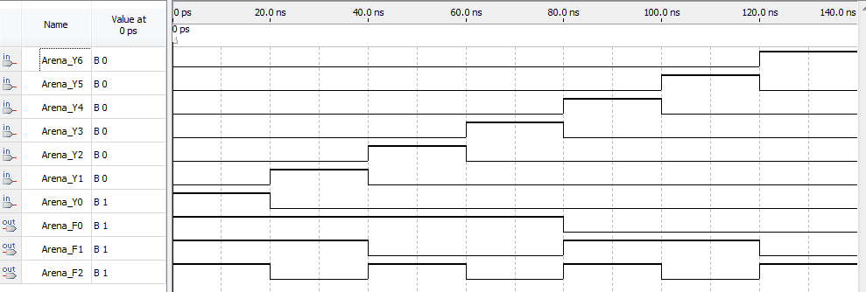

Figure 3512: 8to3 Encoder Waveform

Below in Figure **36** is the results from the testbench file. In this testbench, unlike the last three, I did not include the comparison to the actual 8to3 encoder file, the reason being is the waveforms were too small to be seen properly. In doing so, I left the ones denoted with a UUT on the left side, which stands for **Unit Under Test,** which is the testbench testing the 8to3 encoder.

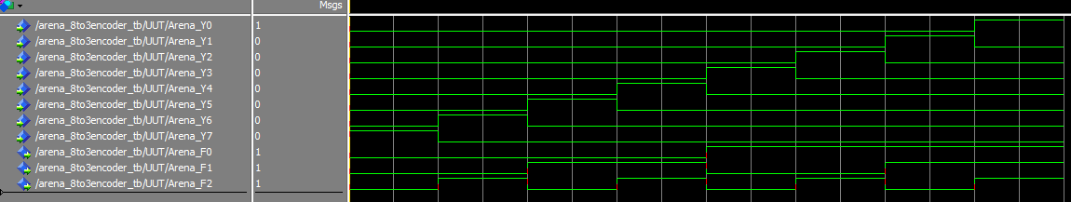

Figure 13: 1-bit Half Adder Testbench

Below in figure **37** is the output from the console for the testbench.



Figure 14: 8to3 Encoder Console Output

Looking at the figures above, we can see the design for 8to3 Encoder is correct. The easiest way to see this is from the output from the console. After running the whole testbench, it finished with no error message. In this test, there was no fail test included, but can be added if wanted.

With that said, there was no output to the console, the testbench passed. Another way to see it’s correct is comparing the Waveform and the Testbench to the truth table. We can see in the figures that the results compared to the truth table are correct, thus confirming our design is correct.

**Section 4) Demonstration Video**

The demonstration video is available upon request and/or possibly submitted already.

**Section 5) Conclusion**

In this lab I designed various circuits, which were a 2to1 Mux, 1-bit Half Adder, 1-bit Full Adder, a 3to8 Decoder, and 8to3 Decoder. I learned various things about designing in VHDL. I learned how to design components, simulate them and then create testbenches for all these components. I also learned about improving readability and more efficient programming, for example using for loops with vectors instead of having the same statement repeated many times. I also learned some debugging skills and learned a more efficient way of organizing my projects from now. Another unexpected thing was how intense designing for FPGA boards can be and the amount of time that must be invested into having a working system, which I did not expect for just the first lab.